第20屆台塑企業應用技術研討會
20th Formosa Plastics Group Applied Technology Conference
研發論文暨海報競賽 (本頁為範例)
Research Paper and Poster Competition (This Page is a Sample)
海報張貼之格式說明
Poster Display Format Instructions
題目：xxxxxxxxxx
Title: xxxxxxxxxx
作者姓名：xxx-xxx-xxx-xxx
Author(s): xxx-xxx-xxx-xxx
公司（學校）及單位名稱：xxxxxx
Affiliated Institution/Department: xxxxxx
Tel: xxxxxx, Fax: xxxxxx, E-mail: xxxxxx

本研討會之海報張貼採一篇論文一面看板
Each paper will be displayed on a single poster board.
此次研討會之海報版面尺寸【全開，A0】為84.1cm (寬) ×118.9 cm (高)，請作者依統一格式製作。
The required poster size for this conference is A0 (84.1 cm width × 118.9 cm height). Authors must follow this standardized format when designing their posters.
1. 海報內容 Poster Content
論文或技術報告的海報內容，除題目及參與者的資料外，依序至少應包含摘要、前言、材料與方法、結果與討論、結論及參考文獻等，格式則請參考本文所提供的範例撰寫繕打。
The poster should include the title and author information, along with the following sections: Abstract, Introduction, Materials and Methods, Results and Discussion, Conclusion, and References. Please follow the provided format as a reference.
2. 海報格式 Poster Format
- 作者姓名以中文書寫（若以英文發表，請加上中文姓名）。若有電子郵件信箱位址（e-mail address），亦請一併提供，有助於對論文內容有興趣的人員，藉以進一步連繫與討論。若為產學合作或國科會之相關成果，請在論文致謝中註明。
Author Name: Must be written in Chinese. If the paper is presented in English, the Chinese name should also be included. If available, an email address should be provided to facilitate further discussions with interested participants. For papers related to industry-academic collaboration or supported by research grants (e.g., National Science and Technology Council projects), please acknowledge them in the acknowledgments section
- 以中文或英文打字。繕打時採用橫式，除題目與作者資料採一欄、置中對齊外，其他分兩欄，採左右對齊。將每張全開海報紙上下側及左右邊各留 5 公分，每欄的寬度是 32 公分，而在兩欄間相隔 6 公分。中、英文字體請分別以 標楷體 與 Times New Roman 書寫。
The poster can be in either Mandarin or English. The text should be formatted in landscape orientation. The title and author information should be centered and displayed in a single-column format. The main content should be in two-column format, aligned to both the left and right margins. Leave a 5 cm margin on all sides (top, bottom, left, and right). Each column should be 32 cm wide, with a 6 cm gap between the two columns.Use DFKai-SB (標楷體) for Chinese text and Times New Roman for English text.

- 圖、表等可以列在文中，或列在參考文獻之後。列在文中者，請儘量靠近文中第一次提及的地方。比較大的圖表，可以含括兩個欄。各圖、表請備說明內容，圖的說明應置於圖的下方，而表的說明則應置於表的上方。
Figures and tables can be placed within the main text or after the references. If included within the text, position them as close as possible to the first mention in the paper. Larger figures or tables may span across both columns. Captions for figures should be placed below the figure, while captions for tables should be placed above the table.

單欄圖例 Single-Column Figure：

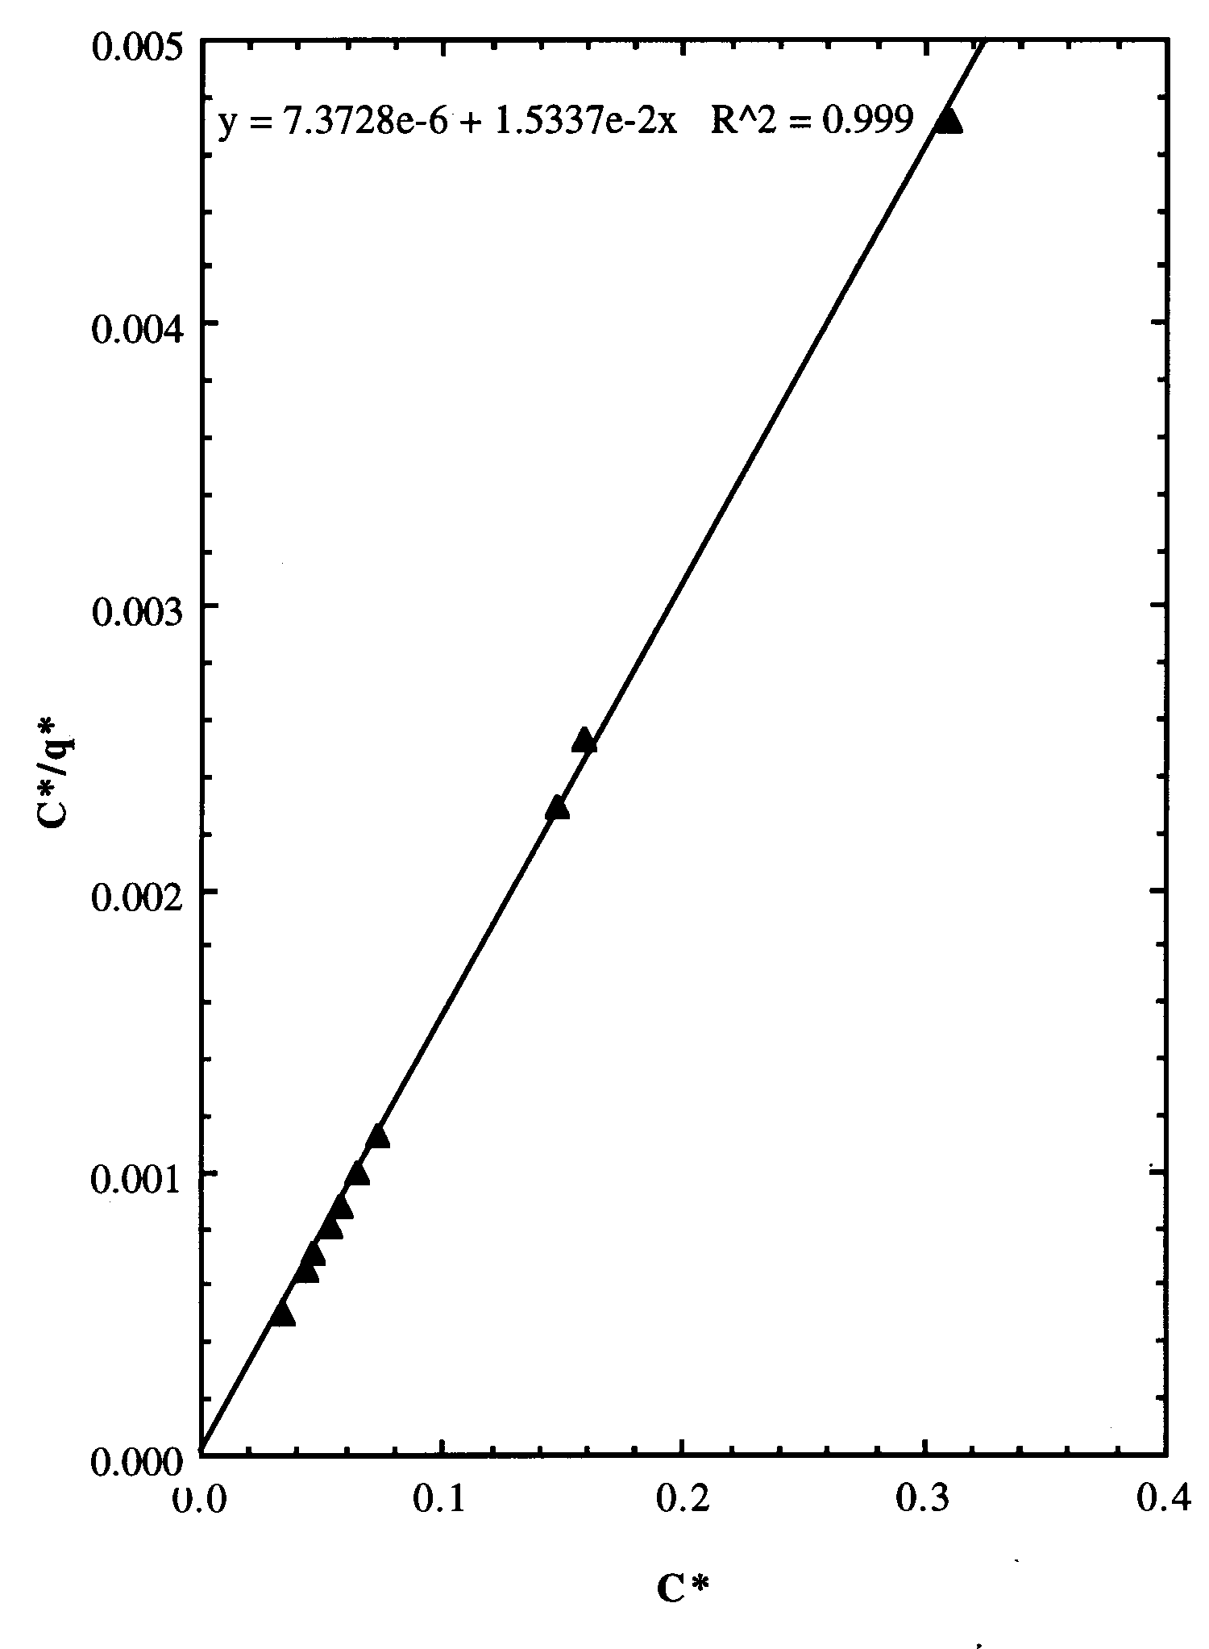
圖1 STREAMLINE DEAE樹脂對GST
酵素的等溫吸附線性關係圖
Figure 1. Isothermal Adsorption Curve of GST Enzyme on STREAMLINE DEAE Resin

